**IN628 2019 Practical 01.1 – Intro to C++ CLI**

1. **Exercise 1**

Create a ***Form*** with a ***Button*** and a ***ListBox***. When the ***Button*** is clicked, write the sequence 0, 2, 4…20 to the ***ListBox***.

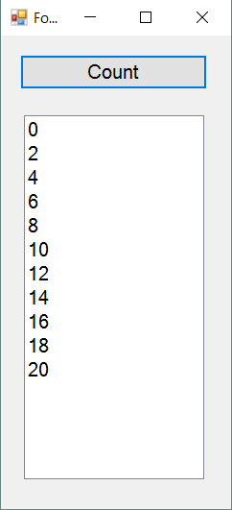

1. **Exercise 2**

Create a ***Form*** with two ***Buttons*** and a ***Timer***. When a ***Button*** is clicked, start the ***Timer*** and for every 100 milliseconds move one ***Button*** five pixels to the left, and the other ***Button*** five pixels to the right. When either ***Button*** hits the edge, that ***Button*** turns green and the ***Timer*** stops.